**Task 3 选做题：卡尔曼滤波**

**#include <iostream>**

**#include <vector>**

**#include <random>**

**#include <Eigen/Dense>**

**#include <opencv2/opencv.hpp>**

**using namespace Eigen;**

**using namespace cv;**

**std::random_device rd;**

**std::mt19937 gen(rd());**

**std::normal_distribution<> noise(0, 1);**

**MatrixXd kf(const std::vector<double>& m) {**

**double dt = 1;**

**double x = 0;**

**double v = 2;**

**Matrix<double, 2, 2> F;**

**F << 1, dt,**

**0, 1;**

**Matrix<double, 2, 2> P;**

**P << 1, 0,**

**0, 1;**

**Matrix<double, 1, 2> H;**

**H << 1, 0;**

**Matrix<double, 1, 1> R;**

**R << 1;**

**Matrix<double, 2, 2> Q;**

**Q << 0, 0,**

**0, 0;**

**Matrix<double, 2, 1> s;**

**s << x, v;**

**MatrixXd f(m.size(), 2);**

**for (std::size_t i = 0; i < m.size(); ++i) {**

**s = F * s;**

**P = F * P * F.transpose() + Q;**

**double mea = m[i] + noise(gen);**

**double y = mea - H * s;**

**Matrix<double, 1, 1> S = H * P * H.transpose() + R;**

**Matrix<double, 2, 1> K = P * H.transpose() * S.inverse();**

**s = s + K * y;**

**P = (Matrix<double, 2, 2>::Identity() - K * H) * P;**

**f.row(i) = s.transpose();**

**}**

**return f;**

**}**

**int main() {**

**std::vector<double> p;**

**std::vector<double> m;**

**double t = 10.0;**

**double d = 0.1;**

**double v = 2.0;**

**for (double i = 0.0; i <= t; i += d) {**

**double tp = v * i;**

**p.push_back(tp);**

**m.push_back(tp + noise(gen));**

**}**

**MatrixXd f = kf(m);**

**int w = 800;**

**int h = 600;**

**cv::namedWindow("KF", cv::WINDOW_NORMAL);**

**cv::resizeWindow("KF", w, h);**

**double mp = *std::max_element(p.begin(), p.end());**

**double mm = *std::max_element(m.begin(), m.end());**

**double mf = f.maxCoeff();**

**cv::Mat c(h, w, CV_8UC3, cv::Scalar(255, 255, 255));**

**cv::line(c, cv::Point(0, h), cv::Point(w, h), cv::Scalar(0, 0, 0));**

**cv::line(c, cv::Point(0, h), cv::Point(0, 0), cv::Scalar(0, 0, 0));**

**int n = 5;**

**double ts = t / n;**

**for (int i = 0; i <= n; ++i) {**

**double tl = i * ts;**

**int xl = w * (tl / t);**

**std::stringstream ss;**

**ss << std::fixed << std::setprecision(1) << tl;**

**cv::putText(c, ss.str(), cv::Point(xl, h - 10), cv::FONT_HERSHEY_SIMPLEX, 0.5, cv::Scalar(0, 0, 0));**

**}**

**int ny = 5;**

**double mv = std::max({ mp, mm, mf });**

**double ys = mv / ny;**

**for (int i = 0; i <= ny; ++i) {**

**double yl = i * ys;**

**int yc = h - h * (yl / mv);**

**std::stringstream ss;**

**ss << std::fixed << std::setprecision(1) << yl;**

**cv::putText(c, ss.str(), cv::Point(10, yc), cv::FONT_HERSHEY_SIMPLEX, 0.5, cv::Scalar(0, 0, 0));**

**}**

**cv::Scalar pc(255, 0, 0);**

**cv::Scalar mc(0, 0, 255);**

**cv::Scalar fc(0, 255, 0);**

**int lw = 1;**

**for (int i = 1; i < p.size(); ++i) {**

**int x1 = w * (p[i - 1] / mp);**

**int x2 = w * (p[i] / mp);**

**int y1p = h - h * (p[i - 1] / mv);**

**int y2p = h - h * (p[i] / mv);**

**int y1m = h - h * (m[i - 1] / mv);**

**int y2m = h - h * (m[i] / mv);**

**int y1f = h - h * (f(i - 1, 0) / mv);**

**int y2f = h - h * (f(i, 0) / mv);**

**cv::line(c, cv::Point(x1, y1p), cv::Point(x2, y2p), pc, lw);**

**cv::line(c, cv::Point(x1, y1m), cv::Point(x2, y2m), mc, lw);**

**cv::line(c, cv::Point(x1, y1f), cv::Point(x2, y2f), fc, lw);**

**}**

**cv::Scalar nc(0, 0, 0);**

**int r = 2;**

**for (int i = 0; i < m.size(); ++i) {**

**int x = w * (p[i] / mp);**

**int y = h - h * (m[i] / mv);**

**cv::circle(c, cv::Point(x, y), r, nc, -1);**

**}**

**cv::imshow("KF", c);**

**cv::waitKey(0);**

**return 0;**

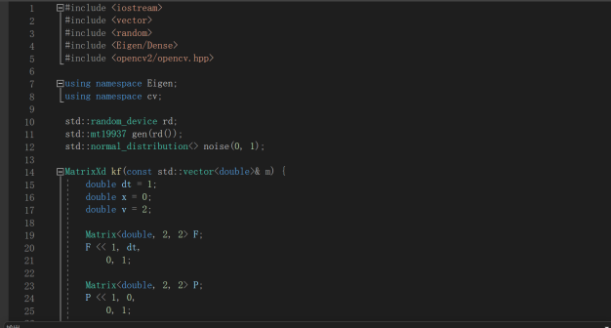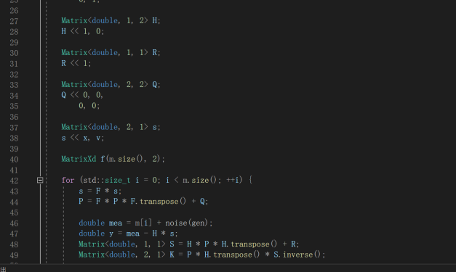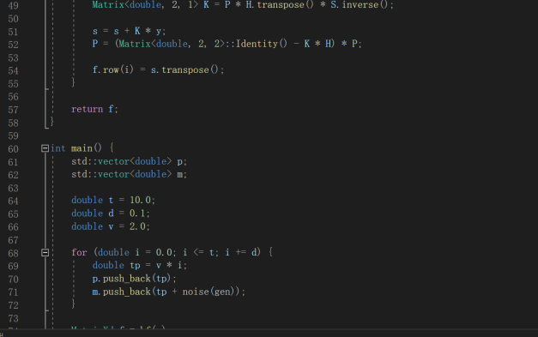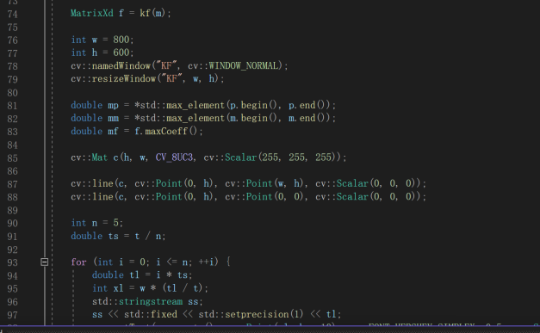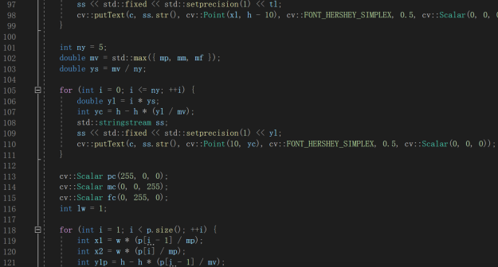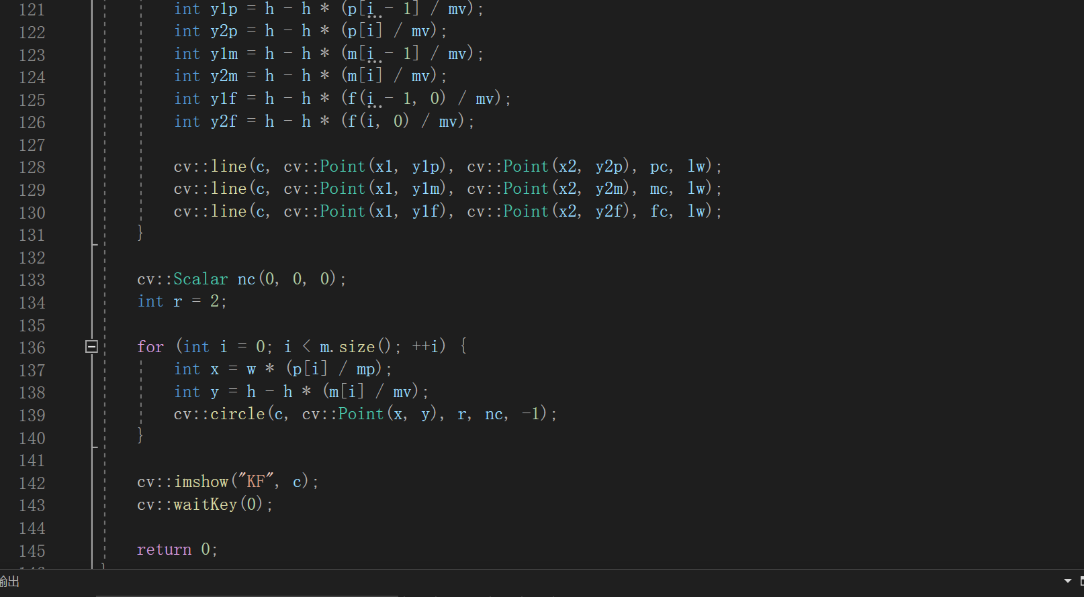

搞懂卡尔曼滤波器的原理后，先建一个卡尔曼滤波器类把计算过程放在里面，再写主函数。

我的模型是一个匀速运动模型，起始位置为0，速度为2m/s,噪声服从分别为（0,1）和（0,10）。然后再以图像模式呈现出来。

以上分别是噪声服从（0,1）分布和（0,10）分布的卡尔曼滤波图像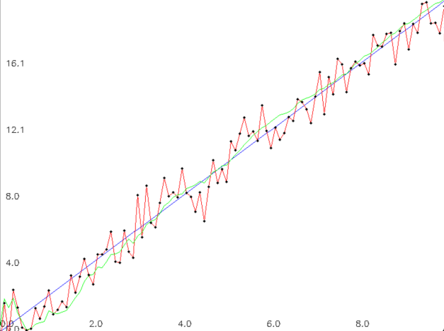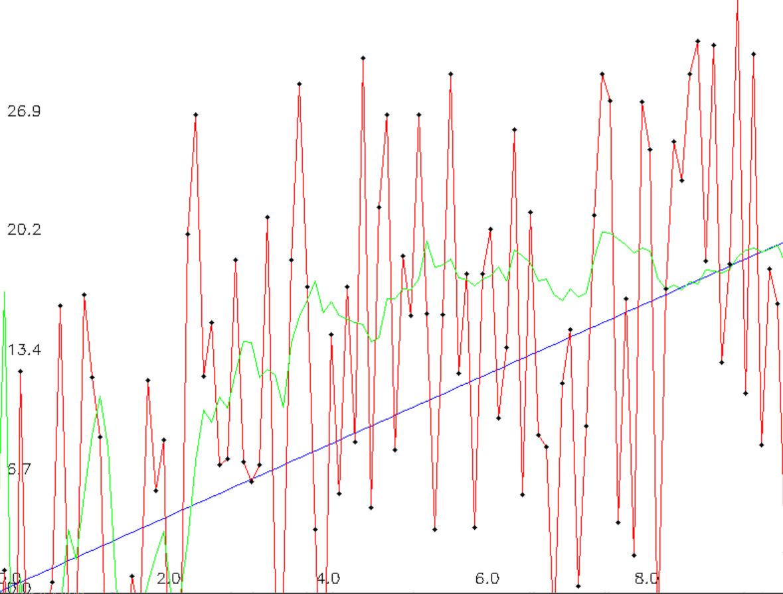

图片路径：\..\pic of kjh\Noise（0,1）.png

\..\pic of kjh\noise (0,10) .png